HW5_490IDS_17

17

October 3, 2016

# For this problem we will start with a simulation in order to find out how large n needs

# to be for the binomial distribution to be approximated by the normal

# distribution.

# We will take m samples from the binomial distribution for some n and p.

# 1.(4pts.) Let's let p=1/2, use the rbinom function to generate the sample of size m.

# Add normal curves to all of the plots.

# Use 3 values for n, 10, 30, and 50. Display the histograms as well as your

# code below.

m = 50  
rbi10 = rbinom(m, 10, 0.5)  
rbi30 = rbinom(m, 30, 0.5)  
rbi50 = rbinom(m, 50, 0.5)  
hist(rbi10, prob = TRUE)  
lines(density(rbi10))

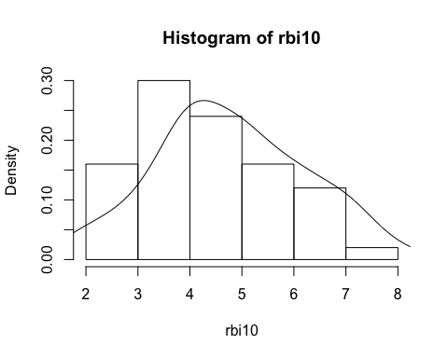

hist(rbi30, prob = TRUE)  
lines(density(rbi30))

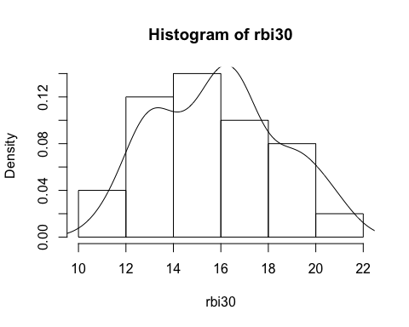

hist(rbi50, prob = TRUE)  
lines(density(rbi50))

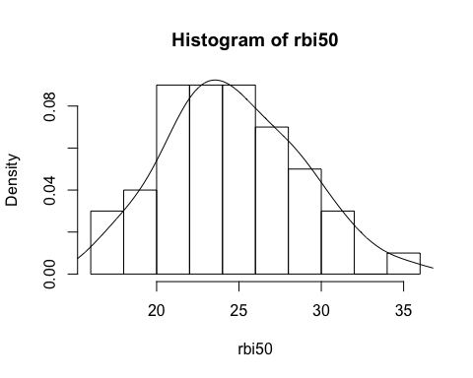

# 1b.)(3pts.) Now use the techniques described in class to improve graphs.

# Explain each step you choose including why you are making the change. You

# might consider creating density plots, changing color, axes, labeling, legend, and others for example.

hist(rbi50, prob = TRUE, main = "density of binominal distribution with n = 50", xlab = "number of success", col = "blue")  
lines(density(rbi50))

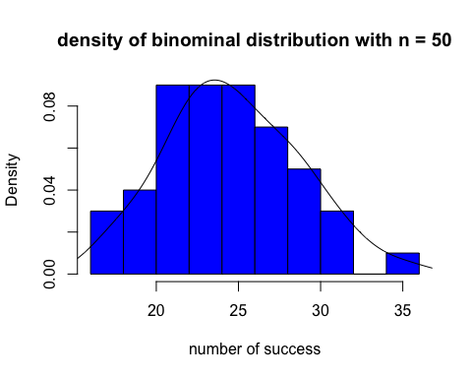

hist(rbi10, prob = TRUE, main = "density of binominal distribution with n = 10", xlab = "number of success", col = "blue")  
lines(density(rbi10))

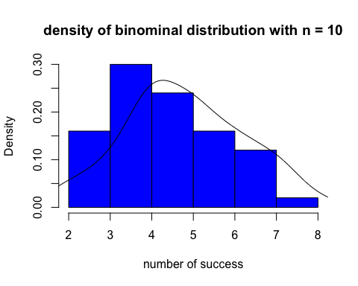

hist(rbi30, prob = TRUE, main = "density of binominal distribution with n = 30", xlab = "number of success", col = "blue")  
lines(density(rbi30))

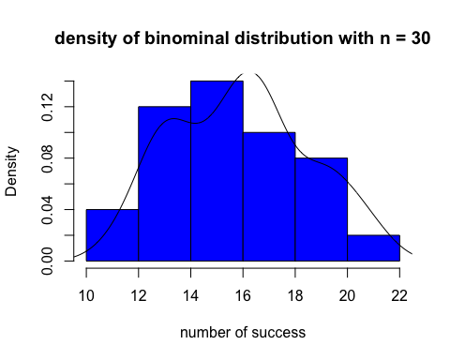

print("I added a title, added x axis label, changed color")

## [1] "I added a title, added x axis label, changed color"

# Q2.) (2pts.)

# Why do you think the Data Life Cycle is crucial to understanding the opportunities

# and challenges of making the most of digital data? Give two examples.

print("1. Consider you have made a successful product and it is very popular. But when will you need to make the next generation of this product? How soon are customers done with the old ones? We need to collect and analyze data to find out the answer and make smart decisions for maximizing the gain. And since the data will be huge and there are so many factors, data life cycle is important.")

## [1] "1. Consider you have made a successful product and it is very popular. But when will you need to make the next generation of this product? How soon are customers done with the old ones? We need to collect and analyze data to find out the answer and make smart decisions for maximizing the gain. And since the data will be huge and there are so many factors, data life cycle is important."

print("2. In a president campaign, how much effort will be needed in each state? This question can be predicted by analyzing datas. Also the past data could be useful. That's why we emphasize on preserving the data smartly.")

## [1] "2. In a president campaign, how much effort will be needed in each state? This question can be predicted by analyzing datas. Also the past data could be useful. That's why we emphasize on preserving the data smartly."

### Part 2

# 3.) San Francisco Housing Data

# 

# Load the data into R.

load(url("http://www.stanford.edu/~vcs/StatData/SFHousing.rda"))

# (2 pts.)

# What is the name and class of each object you have loaded into your workspace?

### Your code below

lapply(housing, class)

## $county  
## [1] "factor"  
##   
## $city  
## [1] "factor"  
##   
## $zip  
## [1] "factor"  
##   
## $street  
## [1] "character"  
##   
## $price  
## [1] "numeric"  
##   
## $br  
## [1] "integer"  
##   
## $lsqft  
## [1] "numeric"  
##   
## $bsqft  
## [1] "integer"  
##   
## $year  
## [1] "integer"  
##   
## $date  
## [1] "POSIXt" "POSIXct"  
##   
## $long  
## [1] "numeric"  
##   
## $lat  
## [1] "numeric"  
##   
## $quality  
## [1] "factor"  
##   
## $match  
## [1] "factor"  
##   
## $wk  
## [1] "Date"

### Your answer

print("county:factor ;city[1] factor;$zip[1] factor;$street[1] character;$price[1] numeric; $br[1] integer;$lsqft[1] numeric;$bsqft[1] integer; $year[1] integer; $date[1] POSIXt POSIXct;$long[1] numeric;$lat[1] numeric;$quality[1] factor;$match[1] factor;$wk[1] Date")

## [1] "county:factor ;city[1] factor;$zip[1] factor;$street[1] character;$price[1] numeric; $br[1] integer;$lsqft[1] numeric;$bsqft[1] integer; $year[1] integer; $date[1] POSIXt POSIXct;$long[1] numeric;$lat[1] numeric;$quality[1] factor;$match[1] factor;$wk[1] Date"

# What are the names of the vectors in housing?

### Your code below

colnames(housing)

## [1] "county" "city" "zip" "street" "price" "br" "lsqft"   
## [8] "bsqft" "year" "date" "long" "lat" "quality" "match"   
## [15] "wk"

### Your answer here

print("county city zip street price br lsqft bsqft year date long lat quality match wk ")

## [1] "county city zip street price br lsqft bsqft year date long lat quality match wk "

# How many observations are in housing?

### Your code below

dim(housing)

## [1] 281506 15

### Your answer here

print("281506 observations")

## [1] "281506 observations"

# Explore the data using the summary function.

summary(housing)

## county city zip   
## Santa Clara County :70424 Oakland : 14730 94565 : 4595   
## Alameda County :60410 Santa Rosa : 9917 94509 : 4302   
## Contra Costa County:59381 Fremont : 9414 95123 : 4023   
## Solano County :23404 San Francisco: 8137 95687 : 3652   
## San Mateo County :22558 Evergreen : 7947 94533 : 3472   
## Sonoma County :21676 Antioch : 7726 (Other):261457   
## (Other) :23653 (Other) :223635 NA's : 5   
## street price br lsqft   
## Length:281506 Min. : 22000 Min. :1.000 Min. : 19   
## Class :character 1st Qu.: 400000 1st Qu.:2.000 1st Qu.: 4000   
## Mode :character Median : 530000 Median :3.000 Median : 5760   
## Mean : 602000 Mean :3.024 Mean : 65939   
## 3rd Qu.: 700000 3rd Qu.:4.000 3rd Qu.: 7701   
## Max. :20000000 Max. :8.000 Max. :418611600   
## NA's :21687   
## bsqft year date   
## Min. : 122 Min. : 0 Min. :2003-04-27 02:00:00   
## 1st Qu.: 1121 1st Qu.:1954 1st Qu.:2004-02-08 02:00:00   
## Median : 1430 Median :1971 Median :2004-10-24 02:00:00   
## Mean : 1624 Mean :1966 Mean :2004-11-01 18:06:12   
## 3rd Qu.: 1882 3rd Qu.:1985 3rd Qu.:2005-07-24 02:00:00   
## Max. :1868120 Max. :3894 Max. :2006-06-04 02:00:00   
## NA's :426 NA's :9202   
## long lat   
## Min. :-123.6 Min. :36.98   
## 1st Qu.:-122.3 1st Qu.:37.50   
## Median :-122.1 Median :37.77   
## Mean :-122.1 Mean :37.78   
## 3rd Qu.:-121.9 3rd Qu.:38.00   
## Max. :-121.5 Max. :38.85   
## NA's :23316 NA's :23316   
## quality   
## QUALITY_ADDRESS_RANGE_INTERPOLATION :170719   
## gpsvisualizer : 31084   
## QUALITY_CITY_CENTROID : 20473   
## QUALITY_EXACT_PARCEL_CENTROID : 17208   
## QUALITY_ZIP_CODE_TABULATION_AREA_CENTROID: 14980   
## (Other) : 3726   
## NA's : 23316   
## match wk   
## Exact :197044 Min. :2003-04-21   
## Relaxed : 30570 1st Qu.:2004-02-01   
## Relaxed; Soundex: 23338 Median :2004-10-18   
## Soundex : 2573 Mean :2004-10-26   
## 1 : 2244 3rd Qu.:2005-07-18   
## (Other) : 2421 Max. :2006-05-29   
## NA's : 23316

# Describe in words two problems that you see with the data.

#### Write your response here

print("1.The maximum price seems to be too big")

## [1] "1.The maximum price seems to be too big"

print("2.Lots of data are missing. There's a lot of NA's in the dataset")

## [1] "2.Lots of data are missing. There's a lot of NA's in the dataset"

# Q5. (2 pts.)

# We will work the houses in Albany, Berkeley, Piedmont, and Emeryville only.

# Subset the data frame so that we have only houses in these cities

# and keep only the variables city, zip, price, br, bsqft, and year

# Call this new data frame BerkArea. This data frame should have 4059 observations

# and 6 variables.

new_housing = subset(housing,housing$city %in% c("Albany", "Berkeley", "Piedmont", "Emeryville"))  
BerkArea = new_housing[c("city","zip","price","br","bsqft", "year")]

# Q6. (2 pts.)

# We are interested in making plots of price and size of house, but before we do this

# we will further subset the data frame to remove the unusually large values.

# Use the quantile function to determine the 99th percentile of price and bsqft

# and eliminate all of those houses that are above either of these 99th percentiles

# Call this new data frame BerkArea, as well. It should have 3999 observations.

BerkArea = subset(BerkArea, BerkArea$price < quantile(BerkArea$price, 0.99, na.rm = TRUE) & BerkArea$bsqft < quantile(BerkArea$bsqft, 0.99, na.rm = TRUE))

# Q7 (2 pts.)

# Create a new vector that is called pricepsqft by dividing the sale price by the square footage

# Add this new variable to the data frame.

BerkArea["pricepsqft"] = BerkArea$price/BerkArea$bsqft

# Q8 (2 pts.)

# Create a vector called br5 that is the number of bedrooms in the house, except

# if this number is greater than 5, it is set to 5. That is, if a house has 5 or more

# bedrooms then br5 will be 5. Otherwise it will be the number of bedrooms.

br5 = BerkArea$br  
br5[br5 >5] <- 5

# Q9 (4 pts. 2 + 2 - see below)

# Use the rainbow function to create a vector of 5 colors, call this vector rCols.

# When you call this function, set the alpha argument to 0.25 (we will describe what this does later)

# Create a vector called brCols of 4059 colors where each element's

# color corresponds to the number of bedrooms in the br5.

# For example, if the element in br5 is 3 then the color will be the third color in rCols.

# (2 pts.)

rCols = c(rainbow(5, s = 1, v = 1, start = 0, end = max(1, 5 - 1)/5, alpha = 1))  
brCols = rCols[br5]

###### 

# We are now ready to make a plot.

# Try out the following code

plot(pricepsqft ~ bsqft, data = BerkArea,  
 main = "Housing prices in the Berkeley Area",  
 xlab = "Size of house (square ft)",  
 ylab = "Price per square foot",  
 col = brCols, pch = 19, cex = 0.5)  
legend(legend = 1:5, fill = rCols, "topright")

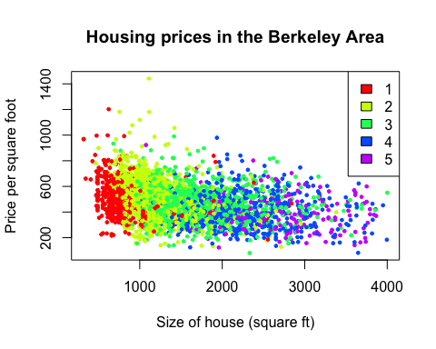

# (2 pts.)

### What interesting features do you see that you didn't know before making this plot?

print("The size of houses is proportional to # of br. As we can see on the graph the colors are actually in blocks.")

## [1] "The size of houses is proportional to # of br. As we can see on the graph the colors are actually in blocks."

# (2 pts.)

# Replicate the boxplots presented in class, with the boxplots sorted by median housing price (slide 45 of the lecture notes)

boxplot(c(BerkArea$price) ~ as.character(BerkArea$city),las = 2, main = "housing price in 4 cities")

